**Stage 6**

**RULES:** USPSA Competition Rules, Latest Edition **COURSE DESIGNER:** Eric Hill TY-48245 (Modified)

|  |  |
| --- | --- |
| **START POSITION: See written stage briefing.** | |
| **STAGE PROCEDURE**  See written stage briefing. | **SCORING**  **SCORING:** Virgina Count 8 rounds.  **TARGETS:** There are 8 cardboard targets.  **SCORED HITS: 1** Best hit per carboard will be scored.  **START-STOP:**  Audible - Last shot  **PENALTIES:** Per USPSA Competition Rules |
|  |  |

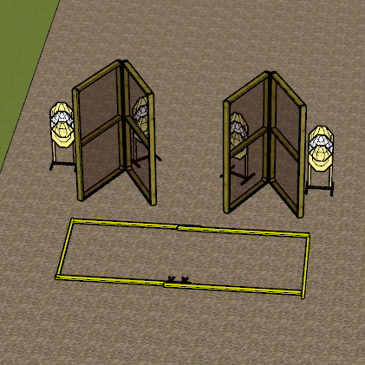

**Written Stage Briefing:**

**Stage 6 –** is an 8-round, 40 point, Virgina Count Short Course. There are 8 cardboard targets. The best 1 hit per cardboard target will be scored.

**Start position** Standing with heels on Xs.

**Handgun**: **Loaded** and holstered with wrists below belt.

**PCC**: **Loaded**, held in both hands, safety on, stock on belt, muzzle pointing directly down range.

On the audible start signal, engage targets from within the shooting area.

**Setup Notes:**

Use the black folding walls.

Ensure no shoot through into stage 7 😊

Be sure to hydrate yourself.